

**www.omniscien.com**

**sales@omniscien.com +66 (2) 381 5869**

**sa**

**Language Studio Enterprise Translation Server**

**Deployment Instructions and Manual**

**Version 1.0 – 27 August-2018**

**Omniscien Technologies Global HQ**   16 Collyer Quay, #22-00, Singapore 049318, Singapore

**Omniscien Technologies Europe**  Stephensonstraat 45, 2723 RMZoetermeer, The Netherlands

**Omniscien Technologies Asia**   141 Major Tower Thonglor, 11thFl., Office 1, SoiSukhumvit 63 (Ekamai), Sukhumvit Rd., Klongton-Nua, Wattana, Bangkok 10110, Thailand

Table of Contents

1. Release Note Summary 1

2. Introduction 2

3. System Requirements 3

3.1. Hardware Requirements 3

3.2. Summary of Software Requirements 3

4. Install Ubuntu 16.04 4

4.1. Download Ubuntu 16.04 64-Bit Server 4

4.2. Install Ubuntu 4

5. Install Docker and LSETS 24

5.1. Install Docker and LSETS 24

5.1.1. Copy the “installation” folder to a temp directory path. 24

5.1.2. Go to installation folder and run script to install docker. 24

5.1.3. Update server IP for accessing a web site. 24

5.1.4. Start LSETS. 24

6. Installing MT Engines 25

6.1. Access the Administrator Page 25

6.2. Uploading and Activating the License 25

6.3. Installing Engine Models 26

6.4. Updating Engine Models 28

6.5. Setting Engine Instances 29

6.6. Setting for Custom View and Configuration 31

6.6.1. CSS 31

6.6.2. XML Data 32

6.7. Resetting the System 34

6.8. Running a test translation 35

7. How to translate 36

7.1. Translation page 36

7.2. Text Translation 36

7.3. File Translation 38

8. Appendices 42

8.1. Appendix A : Setup java script in a system 42

# Release Note Summary

The LSETS 1.0 release introduces the table below summarizes the bugs fixed and enhancement.

|  |  |
| --- | --- |
| **Software Release** | **Enhancements /Bugs Fixed** |
| LSETS (Language Studio Enterprise Translation Server) | **Release initial version**   * Release first version of LSETS |

# Introduction

This document provides instruction on how to set up and install Language Studio Enterprise Translation Server.

Below is an overview of the sections in the documentation.

* Section 3 – System Requirement
  + This section explains the hardware and software requirements needed to install the software.
* Section 4 – Install Ubuntu
  + This section has some important instructions on installing Ubuntu and which versions.
* Section 5 – Install Docker and Language Studio Enterprise Translation Server (LSETS)
  + To install Language Studio Enterprise Translation Server, a Docker will need to be installed onto the system. Instructions here explain how this is done.
  + Instructions on how to install the software.
* Section 6 – Installing MT Engine
  + Instructions on how to download and install MT engines for the software.
* Section 7 – How to translate
  + Instructions on how to Language Studio Enterprise Translation Server (LSETS).

# System Requirements

## Hardware Requirements

The system requirements are specific to each installation depending on their requirements. For 4 MT engines, there is a standard specification provided in a separate Hardware and Pricing document.

Your account manager will provide a uniquely tailored and detailed specification for hardware if the number of engines exceeds 4 on a case by case basis that is specific to the requirements.

## Summary of Software Requirements

1. Operating system Ubuntu 16.04

2. Memory >= 256 GB

3. CPU >= 64 cores

4. Storage >= 2 TB

5. Docker version >= 17.12.0-ce

6. CUDA version 8

# Install Ubuntu 16.04

## Download Ubuntu 16.04 64-Bit Server

Download Ubuntu 16.04 64bit Server from the URL below.

<http://releases.ubuntu.com/16.04/>

Download file name “ubuntu-16.04.4-server-amd64.iso”

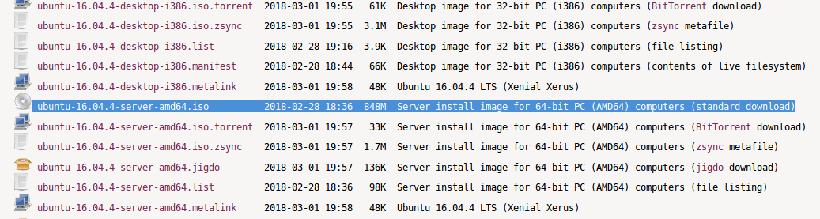

1. Download Ubuntu 16.04 64-bit server

## Install Ubuntu

1. To begin the installation, insert the installation media into your computer and set the computer to boot from this device.
2. When the computer has booted from this media, you will see the following language selection screen appear.
3. Using the keyboard Arrow keys, select the language you would like to use and press Enter. For this tutorial we will be using the default, English.

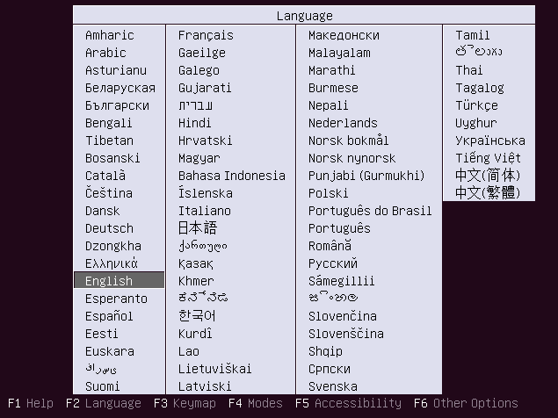

1. Start to install Ubuntu
2. Next, you will be asked to select an action. Since we are installing Linux we will choose the default Install Ubuntu Server by pressing **Enter**.

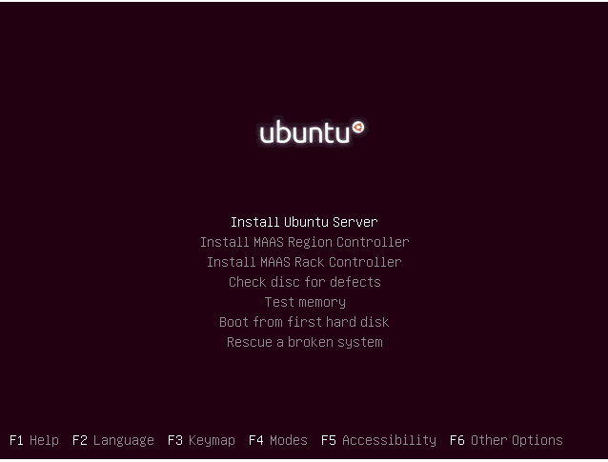

1. Install Ubuntu server
2. Now that we have begun the installation process, the installer will ask for the language that you would like the system to use during installation and operation. Use the keyboard Arrow keys to make your selection and press **Enter**. We will be using the default, English in this tutorial.

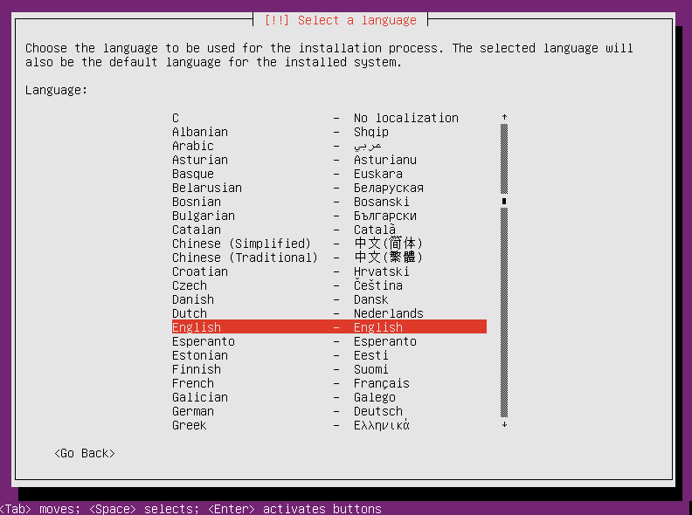

1. Select language screen
2. Once the system language has been selected you will be asked to select the location the system will use. This setting is used for configuring the locality of several system services. We will choose the default, United States by pressing **Enter.**

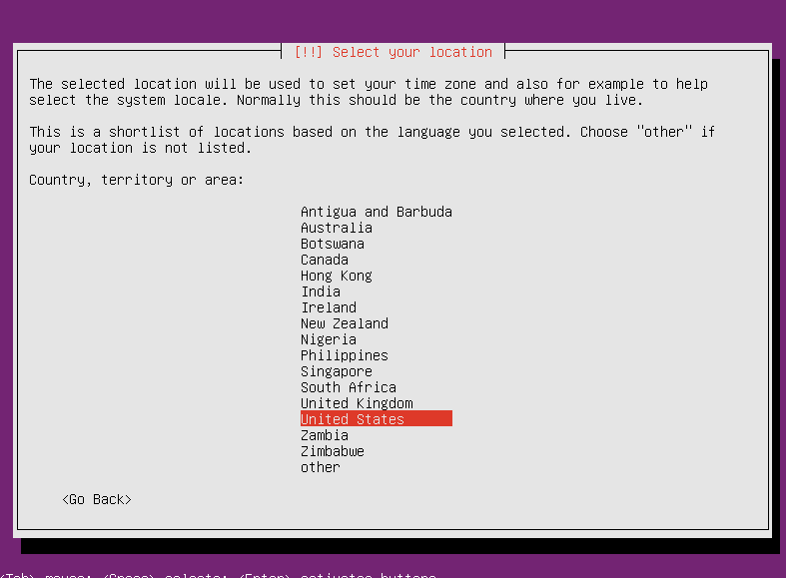

1. Select location screen
2. The installer will now ask whether or not it should try to detect your keyboard layout. You can select **<Yes>** to allow the system to detect the keyboard layout. If it is successful you will automatically skip to step 8.

If the detection is not successful you will need to complete the manual selection process in steps 6 and 7 as if you had selected **<No>.**

In this tutorial we will select **<No>** to allow us to manually select our keyboard layout. Pressing the **Tab** key will allow you to move between selections.

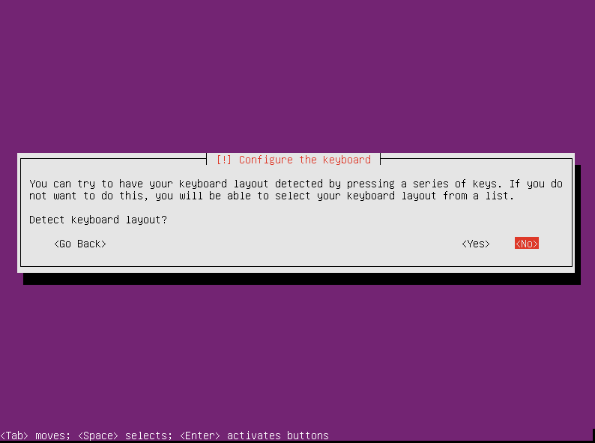

1. Configure the keyboard screen
2. The first step in selecting your keyboard's layout is to choose the Country of Origin for the keyboard. We will choose English (US) which is the default.

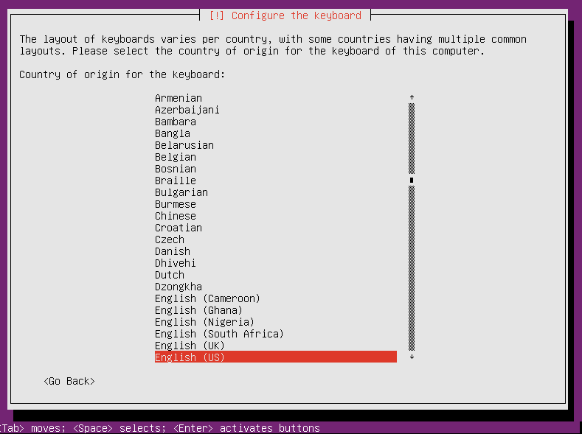

1. Select layout of keyboard screen
2. Next, you will be asked to select the specific layout within the Country of Origin of your keyboard. We will again choose English (US) which is the default.

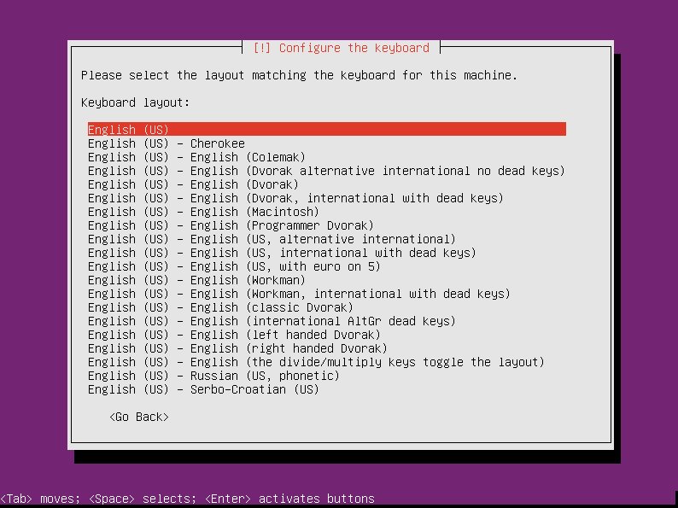

1. Select layout matching the keyboard screen
2. Your system will now try to automatically configure your network options. If it is unable to do this you will be presented with the following failure message: To continue to the network configuration step press the Enter key.

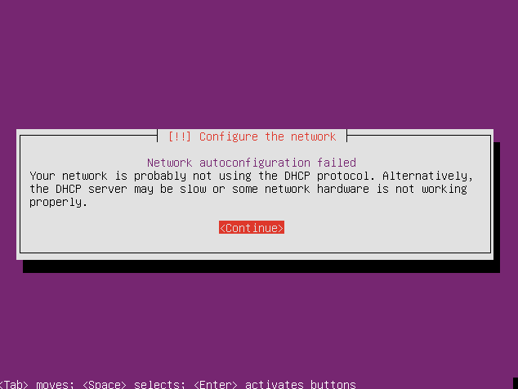

1. Configure the network screen
2. To configure your network settings you will be presented with four options.

The first two options allow you to retry the auto-configuration process. These options are useful if you are able to correct the reason your network was not able to be configured automatically and you wish to retry the automatic configuration.

You can also choose to skip configuring the network by selecting “Do not configure the network at this time”. If you choose to skip configuring the network, you will need to manually configure your network settings after installation completes before your system will be able to communicate with other servers on your network.

For our example, we will select **Configure network manually**. After you have made your selection press the **Enter** key to continue.

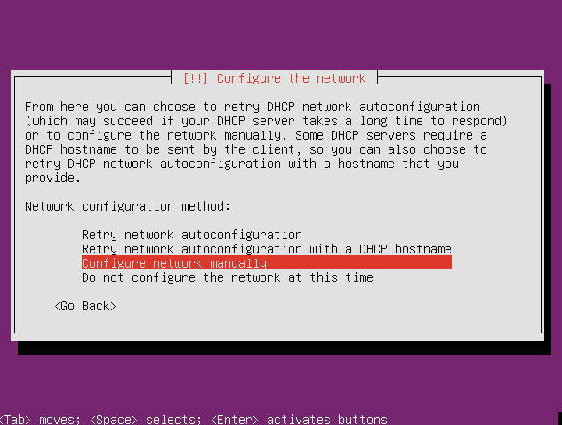

1. Select the network screen
2. Now that we have selected “Configure network manually” we will be asked to enter the Internet Protocol (IP) address for our system. If you do not know your IP address please consult your network administrator for the information.

In this example we will use the IP address 1.2.3.4.

In the field provided, enter the IP address of 1.2.3.4. When done, press the **Tab** key until you get to **<Continue>** and then press the **Enter** key.

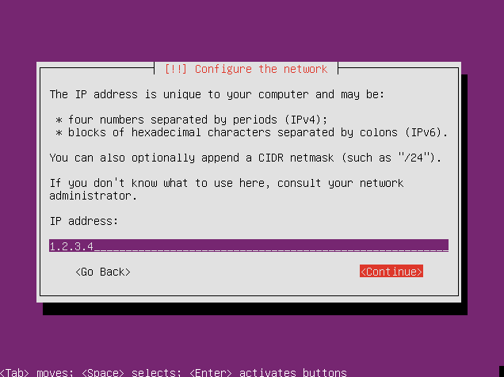

1. Configure IP address screen
2. You will next be prompted to enter the network mask for your network. Again, if you do not know your network mask, please consult your network administrator for the information.

In our example we will use the default 255.255.255.0 as our network mask. Since we are accepting the default network mask of 255.255.255.0 simply press the **Tab** key until you get to **<Continue>** and then press the **Enter** key.

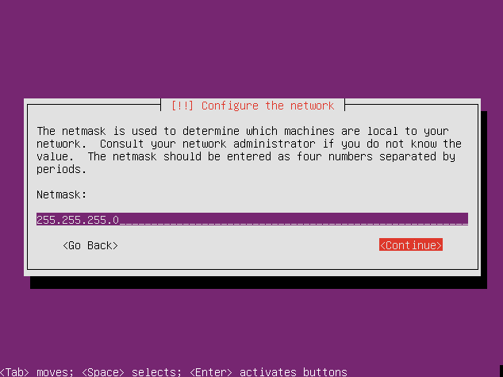

1. Configure Netmask screen
2. In this step we will enter the IP address of the network gateway for our network. Your network administrator can provide this information to you if you do not know what it is.

In our example we will use the address 1.2.3.1 as our gateway address. In the field provided, enter the IP address of 1.2.3.1 for the gateway address. When done, press the **Tab** key until you get to **<Continue>** and then press the **Enter** key.

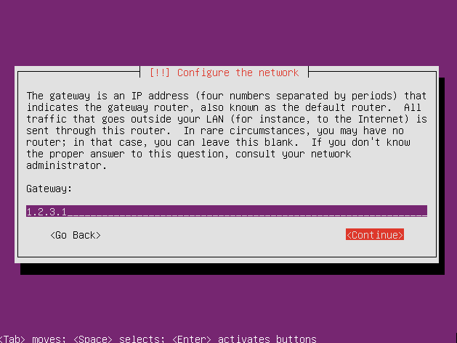

1. Configure Gateway screen
2. In this step we will enter the IP address of the primary name server for our network. Your network administrator can provide this information to you if you do not know what it is.

In our example we will use the address 8.8.8.8 as our name server address. In the field provided, enter the IP address of 8.8.8.8 for the name server address. When done, press the **Tab** key until you get to **<Continue>** and then press the **Enter** key.

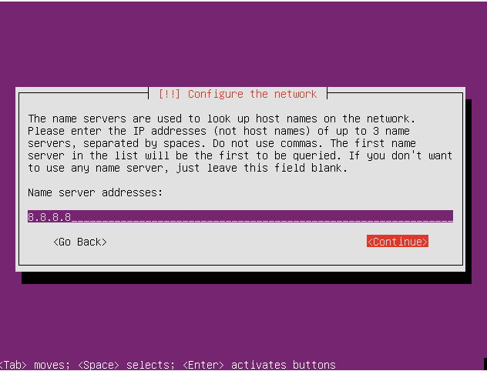

1. Configure name server address screen
2. Next, you will be asked to enter the name that this host will be known as. This name can be a single word (no spaces) and should not contain special characters such as "%". It is common, however, for system administrators to utilize a dash "-" in their host names. (Such as web-server-1).

When selecting your host's name, it is important to select a meaningful name to prevent confusion with other hosts on your network. Since the host we are building in this tutorial will not appear on a network we will leave the host name as its default value of Ubuntu. Press the **Tab** key until you get to **<Continue>** and then press the **Enter** key.

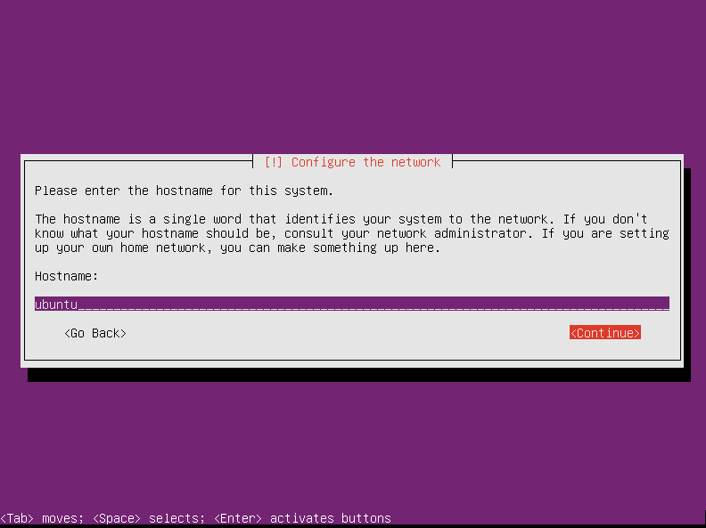

1. Configure Host name screen
2. In this step, you will be asked to enter the full name of the primary user of the system. (Note: On Ubuntu systems, this user is NOT the root super user but will have administrative capabilities)

On our system we will set this user name to TechOnTheNet but you may choose to use your full name (e.g. John Doe). Press the **Tab** key until you get to **<Continue>** and then press the **Enter** key.

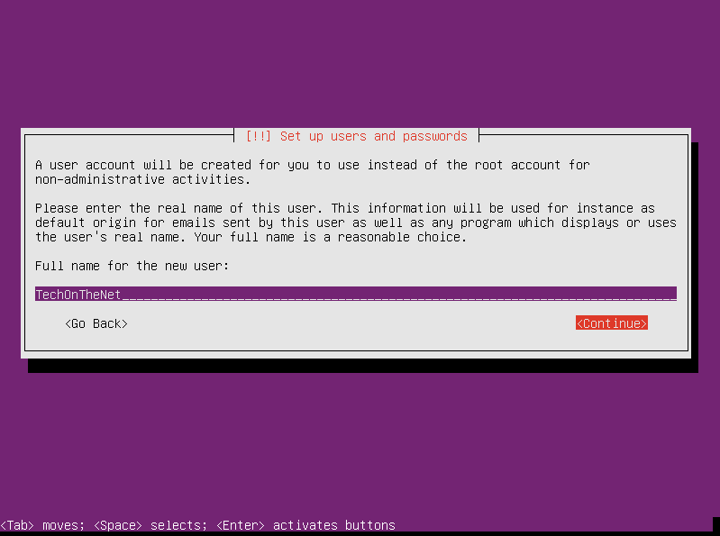

1. Configure full name for new user
2. Next, we will enter the user name we will use to log in. This name should be lowercase and not include spaces or non-alphanumeric characters (characters that are not numbers or alphabetic characters). In our example we will use techonthenet for our user account. Press the **Tab** key until you get to **<Continue>** and then press the **Enter** key.

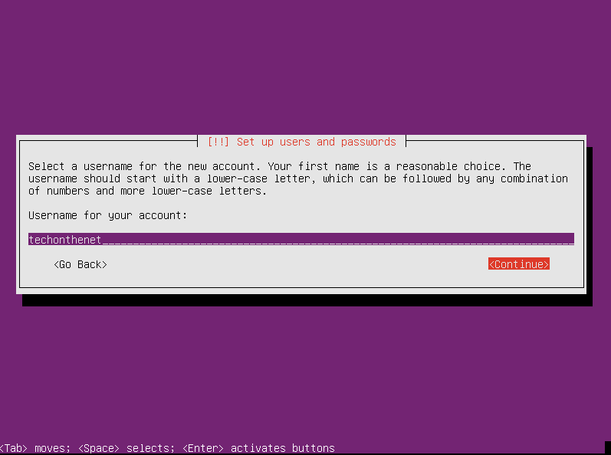

1. Configure username account

On this screen, you will need to enter the password you would like to use for the techonthenet user account. It is important to choose a strong password that cannot be easily guessed and that you will remember! (typically, strong passwords are more than 8 characters long and contain upper/lower case characters and have numbers or special characters such as a "$".) After entering the password, press the **Tab** key until you get to **<Continue>** and then press the **Enter** key.

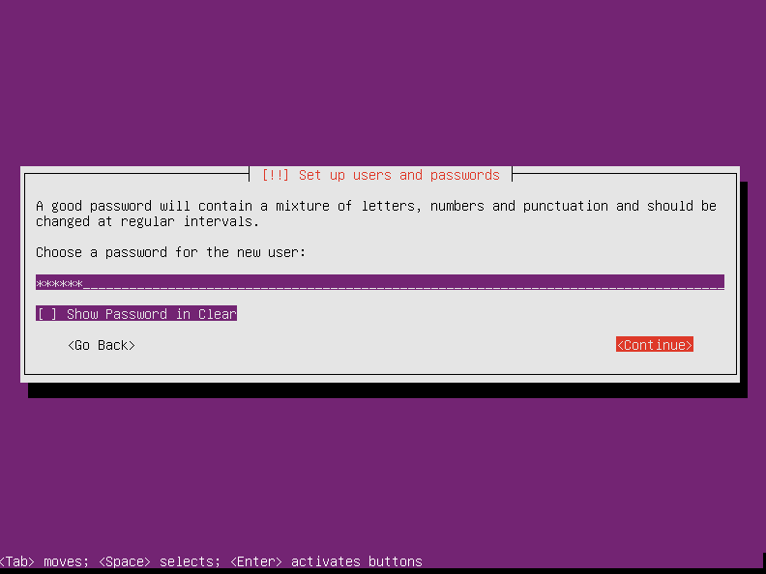

1. Configure password
2. In this step, you will be asked to re-enter the password you used from the previous step. This is to ensure that the passwords match. After re-entering the password, press the **Tab** key until you get to **<Continue>** and then press the **Enter** key.

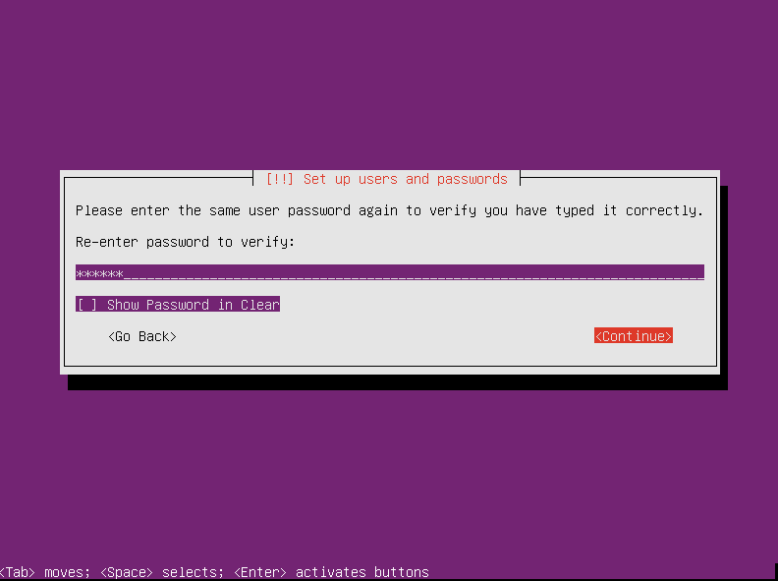

1. Re-enter password screen
2. If you entered a weak password, the installer will prompt you to confirm that you want to proceed or re-enter a stronger password. Since our machine will only be used for this tutorial, we will accept the risk and continue. If you choose <No> you will have to repeat the password selection (steps 11 and 12). If you choose **<Yes>** you will proceed to the next step.

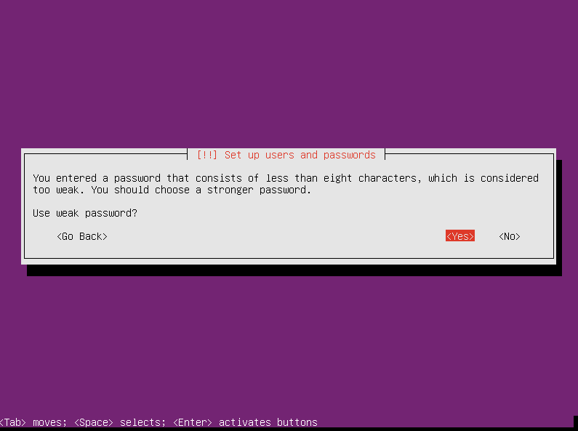

1. Check strong password screen
2. Ubuntu allows you to encrypt your home directories for security. This is useful for situations where users require security on items they keep in their home directories.

For this tutorial, we will select **<No>** and not encrypt the home directories.

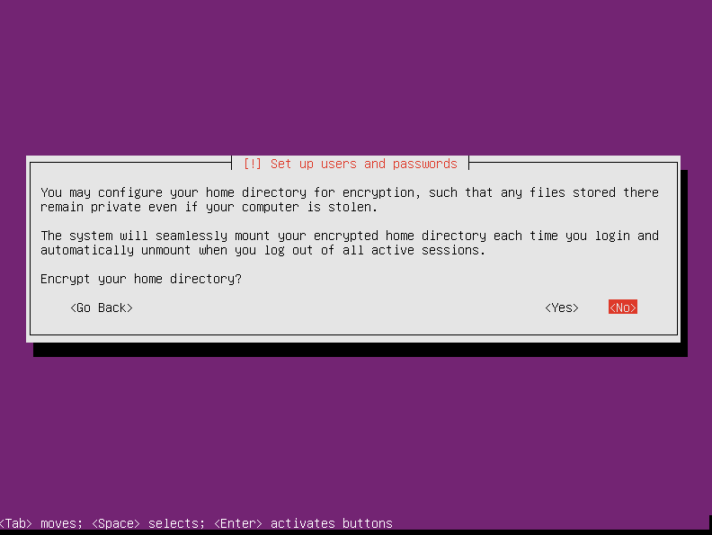

1. Encrypt home directory screen
2. In this step, you will configure the clock and choose the time zone your computer will use. The system time services will use this setting to display the correct local time. On our system, we will select the Pacific time zone.

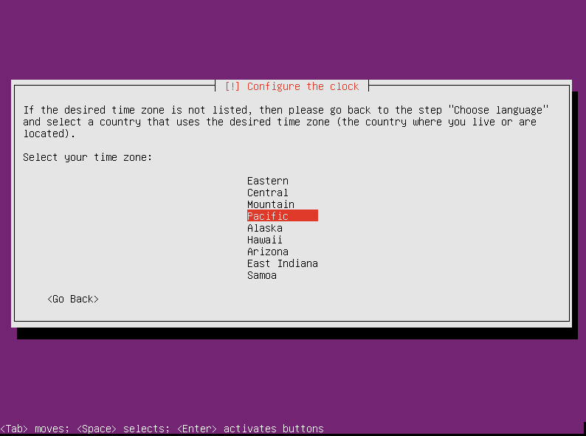

1. Select time zone screen
2. Ubuntu will now ask you to configure your hard disk partitions. There are several choices available:

**Guided - use entire disk**

* Creates a non-LVM (Logical Volume Manager) partition layout which follows a more traditional UNIX layout. This scheme creates fixed partitions which cannot be easily changed without re-installation or advanced knowledge of Linux.

**Guided - use entire disk and set up LVM**

* Allocates a small boot partition and places the remaining available disk space into a logical volume in which the other partitions will be created. LVM allows additional flexibility in how the logical volume will be laid out or changed in the future.

**Guided - use entire disk and set up encrypted LVM**

* Creates a similar partition layout as the previous option but encrypts the logical volume with a password.

**Manual**

* Allows manual configuration of disk partitions. This is an advanced mode typically used by experienced UNIX administrators and allows full control over the layout of the partitions.

For this tutorial we will choose the second option which is “Guided - use entire disk and set up LVM”.

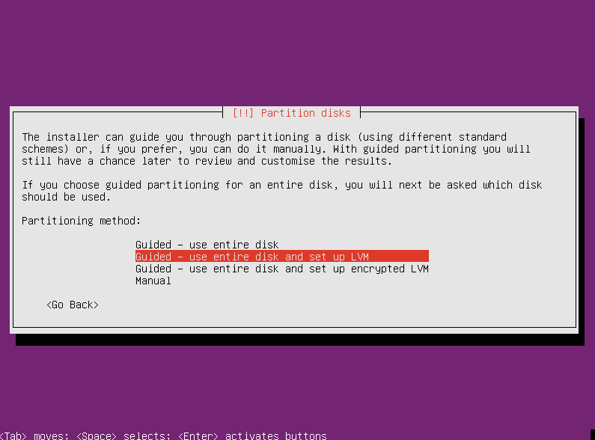

1. Partition disks screen
2. Next we will need to select the hard disk that we will apply the hard drive partitions to. Since our computer contains only one hard drive we can accept the defaults and continue. If your system has more than one hard disk, you will need to select the appropriate hard drive your system is set to boot from.

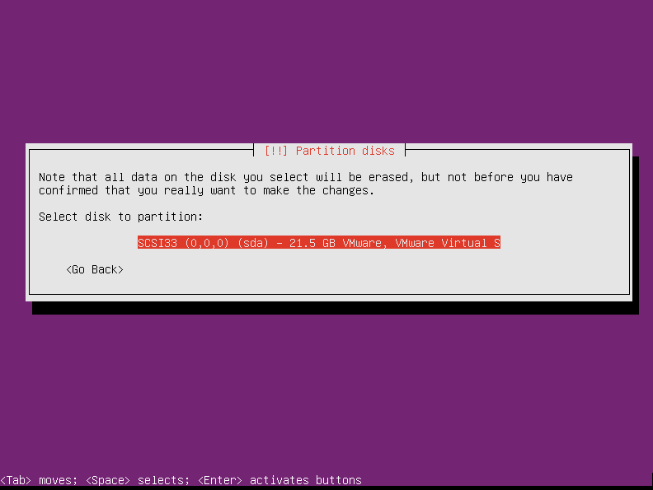

1. Select disk to partition screen
2. The installer will now confirm that you are prepared to write the partition layout to the hard disk you have selected. If you are ready to apply your selected partition layout to the hard disk, tab to **<Yes>** and then press the **Enter** key.

|  |
| --- |
| IMPORTANT: This is your last chance to abort the installation before your hard disk is erased. Please be sure you have backed up any data you would like to keep! |

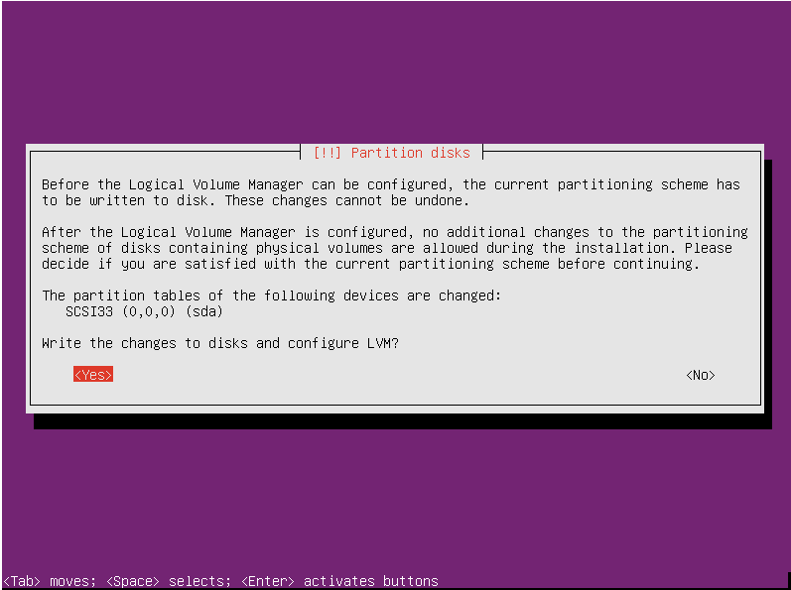

1. Changing disk partition screen
2. In this step you will be entering the amount of hard disk space you would like the installer to use for Ubuntu Linux Server. The installer will by default fill in the total amount of space available on your hard disk but you can lower this value to leave some space available for other purposes.

Values are typically entered in MB (megabytes), GB (gigabytes) or TB (terabytes).

We will leave the value unchanged which will tell the installer to utilize all available hard disk space. Press the **Tab** key until you get to **<Continue>** and then press the **Enter** key.

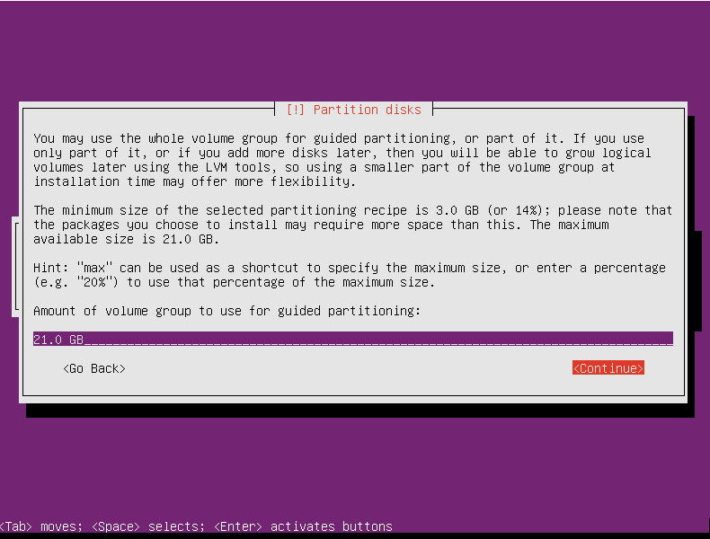

1. Partition processing screen
2. The installer will confirm that you are ready to write the partition information to the hard disk. Since these settings are correct and we are ready to write the partition information we will select **<Yes>** to continue.

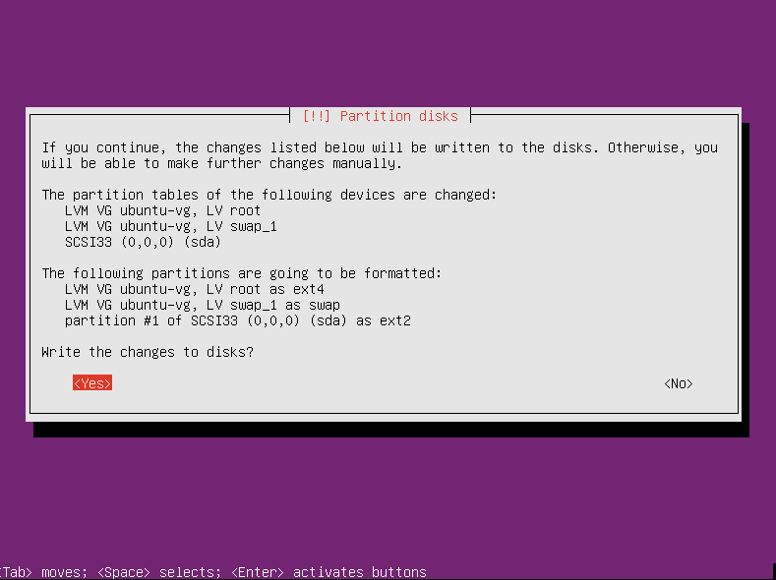

1. Partition disk to detail screen
2. If you utilize a HTTP proxy on your network, you can enter the proxy information on this screen. In this tutorial we will not provide any HTTP proxy information so we press the **Tab** key until we get to **<Continue>** and then press the **Enter** key.

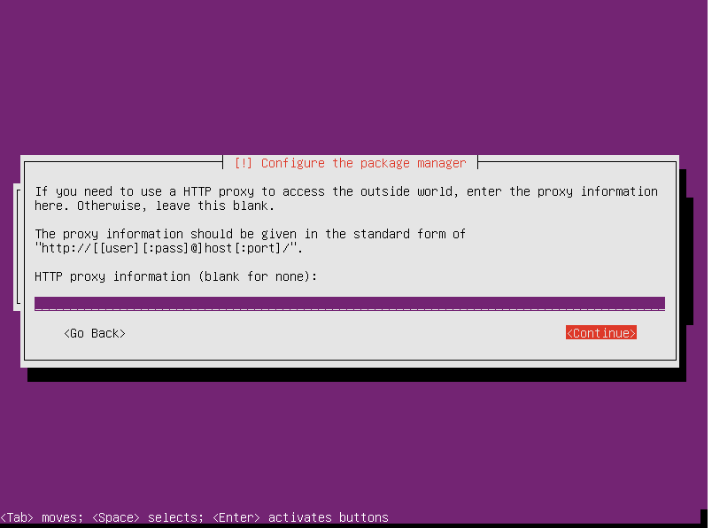

1. Setting HTTP proxy screen
2. Next, the installer will ask if you would like to configure automatic system updates. The options available are:

**No automatic updates**

* The system will not apply any updates automatically. System updates will require manual intervention by a system administrator.

**Install security updates automatically**

* Updates which resolve security issues will be applied automatically once per day.

**Manage system with Landscape**

* System updates will be managed externally by the Landscape application suite.

Please select **No automatic updates**

1. At this step we will be asked to select any additional software or services we would like to install on the host. By default the standard system utilities option is selected. This option contains many of the system utilities that we will need to manage our system so we will leave it selected.

Since we would like to be able to log into the host using secure shell (SSH) from another host on the network we will also select Opens’ server.

You can select a menu option by pressing the **Space Bar**. Moving between menu items can be accomplished by using your keyboard's Arrow keys.

When you are finished selecting the software, select **<Continue>.**

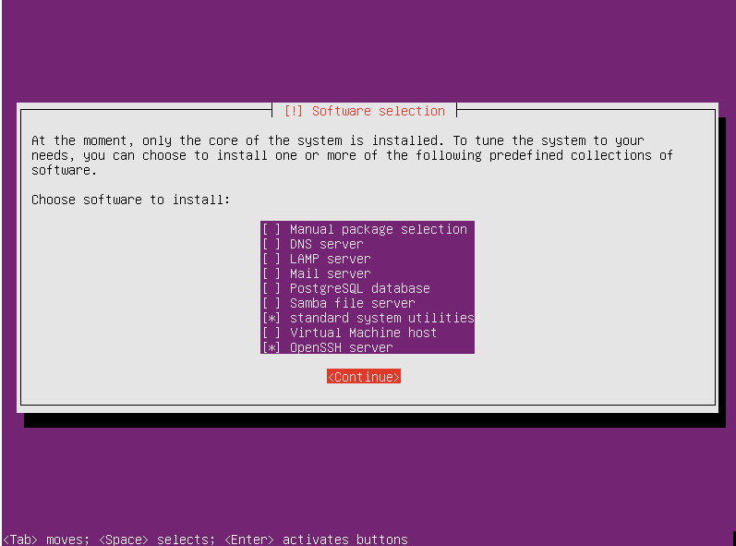

1. Software selection screen
2. The system will now ask to install the GRUB boot loader onto the master boot record of your hard disk.

GRUB is used during the boot up process to enable Ubuntu Linux Server to load.

We will select **<Yes>** to install the GRUB boot loader.

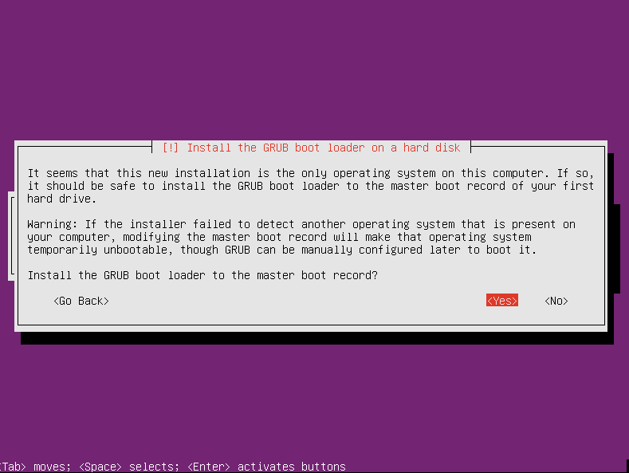

1. Confirm install GRUB screen
2. **The installation is complete!**

The installer will now prompt you to reboot the computer.

Select **<Continue>** to reboot into Ubuntu Linux Server.

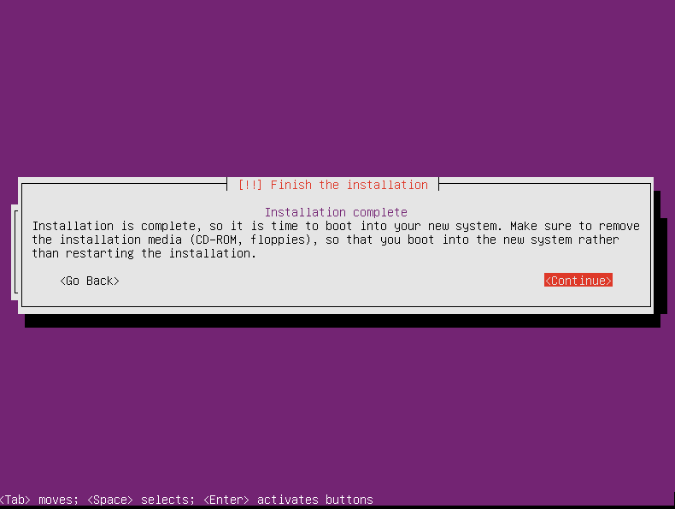

1. Finish the installation screen
2. If all goes well in a few minutes you will see a login prompt similar to the following screenshot. Congratulations, you've installed Ubuntu Server Linux!

You can now log in using the user name and password you configured during steps 10, 11 and 12

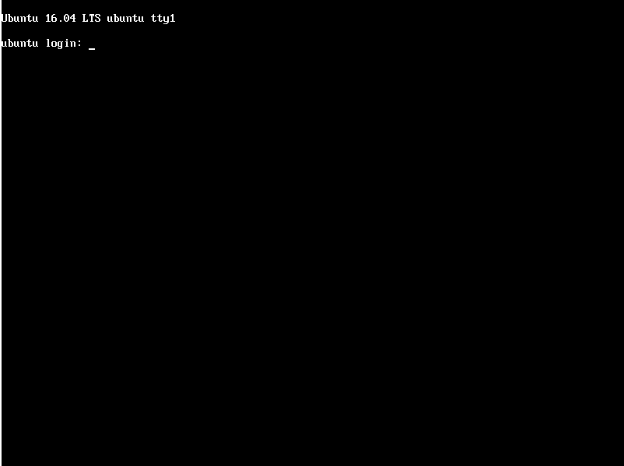

1. Login screen

# Install Docker and LSETS

Docker is a tool designed to make it easier to create, deploy, and run applications by using containers.

## Install Docker and LSETS

### Copy the “installation” folder to a temp directory path.

|  |
| --- |
| cp -r /your-path/installation /home/administrator/ |

### Go to installation folder and run script to install docker.

|  |
| --- |
| cd /home/administrator/installation ./installation.sh |

Wait until finish.

### Update server IP for accessing a web site.

Go to host docker machine and edit the XML configuration file.

|  |
| --- |
| nano /home/dockeruser/lsets/data/services/lsetx/resources/LSETXServerConfig.xml   <api enabled="1">  <apikey>RESTAPIKey-lsetsruntime</apikey>  <apiurl>http://[host-ip-address]:9050/lsrestapi/LSRESTAPI.V5.jsp</apiurl>  </api> |

### Start LSETS.

|  |
| --- |
| /home/dockeruser/lsets/run-all.sh |

# Installing MT Engines

Now that the software has installed, the next part is to download and install your MT engines.

## Access the Administrator Page

LSETS Administrator page requires user to login with the following Login details.

Username: admin

Password: p@s$w0rd

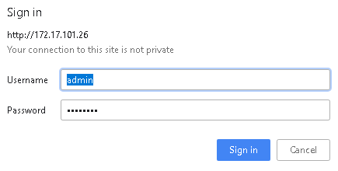

To access the engines, the first step is to access the LSETS Administrator. The Administrator page will be as follows: (please change the IP address where appropriate).  
  
http:// 172.17.101.26/lsetx/admin/license.jsp

To get started, you will need to upload and activate the license.

## Uploading and Activating the License

The License tab gives you an overview of your license details.

The first thing you will do is upload the License. This will be in the package sent to you. Click **Choose File** and upload the license.



1. Activating license screen

Once uploaded, a confirmation that the License has updated successfully and is now activated. You will now be able to access the Engine models.

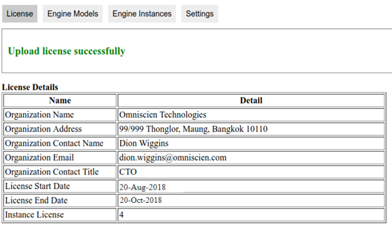

1. License detail screen

## Installing Engine Models

1. Download engine model into your machine.
2. Copy model file from your machine to a docker host machine.

|  |
| --- |
| scp -C your-local-path/engine-model-file-name.zip root@[docker-host-ip]:/home/dockeruser/lsets/data/services/lsetx/resources/enginezip/ |

Please change yellow highlight to your information.  
 your-local-path = The path of downloaded engine model in your local machine.   
engine-model-file-name.zip = The file name of engine model.  
docker-host-ip = The IP address of your docker host machine.

1. Modify owner file by run a command below.

|  |
| --- |
| /home/dockeruser/lsets/data/services/lsetx/resources/enginezip/* |

1. After finished copy model engine file, you can start to install engine model.

**Step to install engine model:**

1. In the **Engine Models** tab, you will see engine model list located in /home/dockeruser/lsets/data/services/lsetx/resources/enginezip/

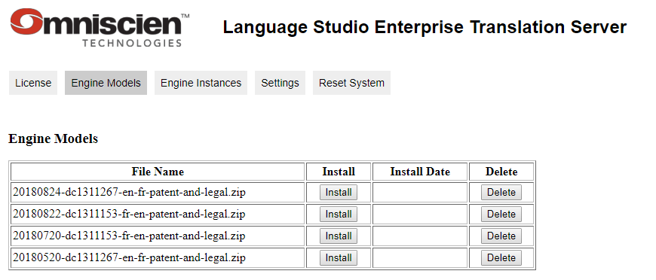

1. Engine model screen
2. In case no engine model in path (/home/dockeruser/lsets/data/services/lsetx/resources/enginezip/), system should display message.

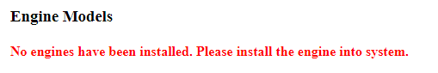

1. No engine message
2. Please click Install button to install each engine.

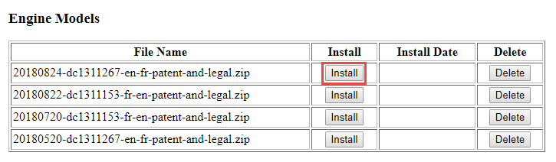

1. Install engine model
2. Once installed, the screen will show message and install date.

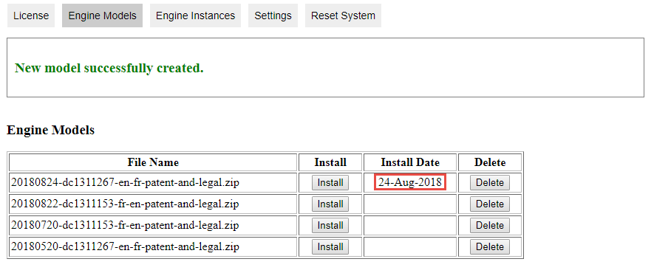

1. Install engine model successful

## Updating Engine Models

Note – This step is not for initial set up, but for later use when Omniscien Technologies send on an updated version of the engine.

If Omniscien Technologies send an updated model of an engine, then please delete the appropriate engine and follow the step to install engine model.

**Step to delete engine model:**

1. In the **Engine Models** tab, you will see engine model list located in /home/dockeruser/lsets/data/services/lsetx/resources/enginezip/
2. Click **Delete** button to delete the appropriate engine.

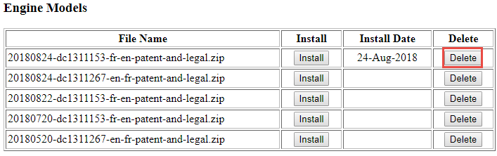

1. Delete engine model
2. System should display confirm message to confirm delete engine model.

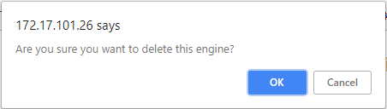

1. Confirm message to delete engine model
2. Once deleted, the screen will show message and clear install date.

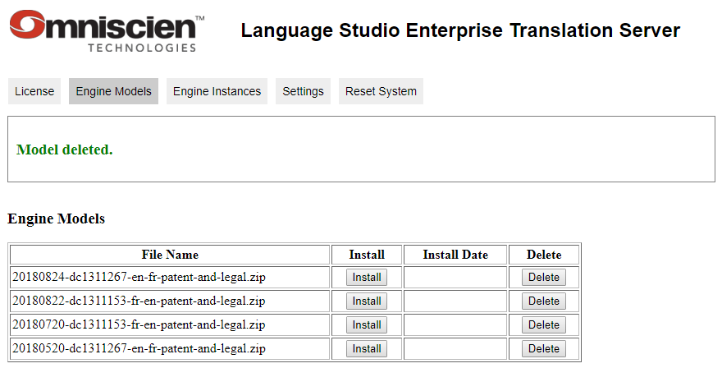

1. Engine model deleted
2. After that you can install the updated engine model. Please follow the step to install engine model.

## Setting Engine Instances

For the translations to run, you need to set the engines up on instances of the Translation server. To do this, please follow the instructions below.

Once the engine models have been applied, you can set engines to the available instances. The amount of Instances available depends on your License (under Instance License). So, you could have four separate engines on four separate instances.

The container is translation machine. You should input Container No. following your translation machine amount.

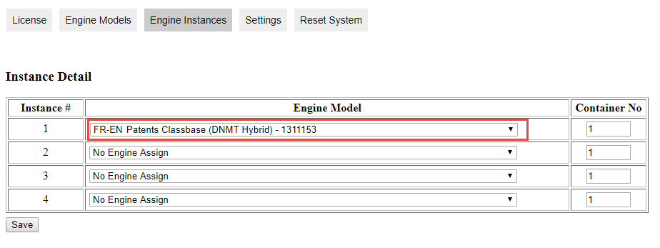

1. Setting engine instance

Or for example have two engines on two instances like below. The more instances the engine is assigned to, the likelihood of faster translations.

Select the relevant engine model from each instance then click the Save button.



1. Setting one engine on many instances

Once saved, a confirmation will appear the instances have been saved.

1. Save engine instances successful

## Setting for Custom View and Configuration

### CSS

You can configure your web page to your own views, for example font style, font size, font colour and background colour. To do this, you need a little experience with CSS.

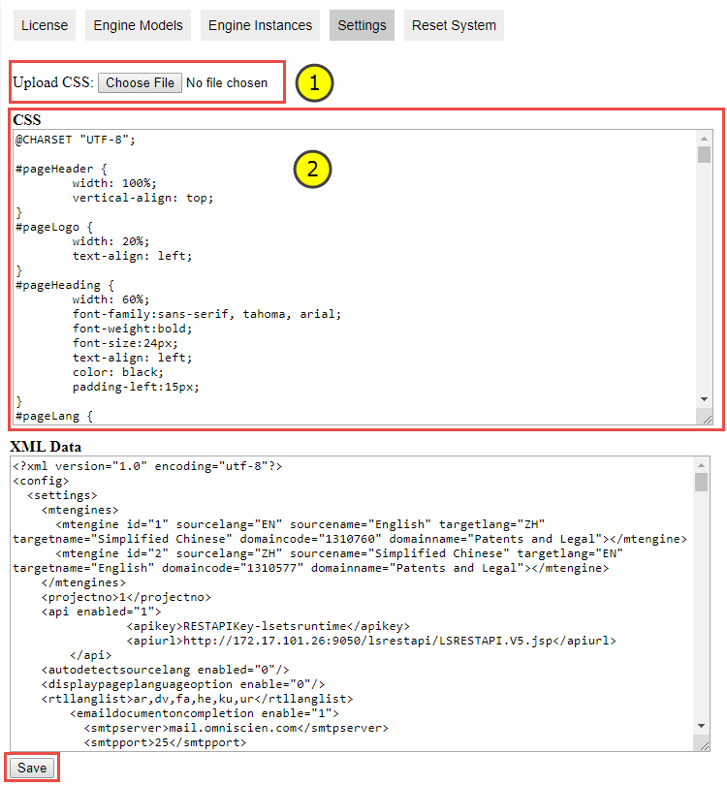

1. Setting CSS screen

Below is step to setting CSS.

1. In the **Settings** tab, click upload your own CSS file (see no.1). Once done, a Success message will appear.



1. Upload CSS file successful
2. Edit CSS in box no.2, please check the CSS syntax, if some syntax wrong, it will not impact.
3. After finish editing, click **Save** to save the changes. Once done, a Success message will appear.



1. Save CSS file successful

### XML Data

You can change your own logo, company name your, mail server, etc. To do this, you need a little experience with XML.

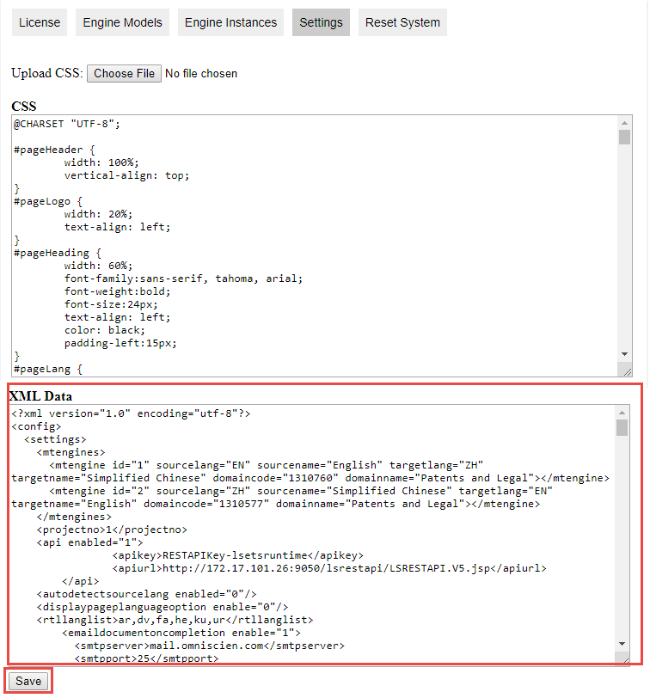

1. Setting XML screen

Below is step to edit XML.

1. In the **Settings** tab, edit XML in red box.
2. After finish editing, click **Save** to save the changes. Once done, a Success message will appear.



1. Save changed XML
2. Editable parameters

|  |  |  |  |
| --- | --- | --- | --- |
| No. | Name | Description | Value example |
| 1 | **API configuration** | | |
| 2 | apikey | API key, please contact sale to get API key. |  |
| 3 | apiurl | URL of API http://172.17.105.172/lsrestapi/LSRESTAPI.V5.jsp | Please change your IP in yellow highlight |
| 4 | rtllanglist | List language for align right. | ar,dv,fa,he,ku,ur |
| 5 | **SMTP configuration** | | |
| 6 | Smtpserver | SMTP server (mail server) | mail.omniscien.com |
| 7 | smtpport | SMTP port | 25 |
| 8 | smtpusername | SMTP username |  |
| 9 | smtppassword | SMTP password |  |
| 10 | smtpencryptiontype | SMTP encryption type | None |
| 11 | **Mail configuration** | | |
| 12 | sendernamedefault | Sender name | Translation Admin |
| 13 | Senderemaildefault | Sender email | LSETX@omniscien.com |
| 14 | subjectdefault | Mail subject | The translation output |
| 15 | bodydefault | Mail body | Dear all,  Please find out the translation output in attached file. |
| 16 | **Setting language in translation page** | | |
| 17 | lang | Language in list box for translation web. If you have new language and want to change text on screen, add new language in here.  id : Abbreviation language name : Language name | <lang id="en" name="English"> |
| 18 | logourl | Path of logo picture | /resources/images/Logo.png |
| 19 | pageheading | Heading text | Private and Secure Translation |
| 20 | buttontranslate | Text for translate button. | Translate |
| 21 | buttonreset | Text for reset button. | Reset |
| 22 | buttoncopy | Text for copy button. | Copy |
| 23 | cleartooltip | Text for tool tip of clear text box | Clear Text |
| 24 | copytooltip | Text for tool tip of copy button. | Copy to Clipbord |
| 25 | textheaderlabel | Text on input box. | Text |
| 26 | textplaceholder | Leading text into input text box. | Enter text here... |
| 27 | translationplaceholder | Leading text into output text box. | Text translation... |
| 28 | headinglable | Text on file translation area. | Document(s) |
| 29 | draglabel1 | Text for drag and drop file (line 1) | Drag and Drop Files |
| 30 | draglabel2 | Text for drag and drop file (line 2) | into this Box |
| 31 | draglabel3 | Text for drag and drop file (line 3) | or |
| 32 | buttonbrowse | Text for browse for file button. | Browse for Files |
| 33 | documentoutputformatlabel | Text for output format option. | Output Format |
| 34 | sameasdocumentlabel | Text for same as input document. | Same as Document |
| 35 | htmllabel | Text for HTML output. | HTML |
| 36 | textlabel | Text for text file output. | Text file |
| 37 | documentaftertranslationlabel | Text for after translation option. | After Translation |
| 38 | downloadlabel | Text for download document. | Download Document |
| 39 | emaildocumentlabel | Text for email document as attachment. | Email Document as Attachment |
| 40 | selectfile | Text for select file. | Select the engine and click translate button. |
| 41 | tblfilename | Text for file name. | Document(s) to translate |
| 42 | tblsize | Text for file size. | Size |
| 43 | tbllanguagepair | Text for language pair. | Language Pair |
| 44 | tblstatus | Text for translation status. | Status |
| 45 | statusqueue | Text for queue status. | Queue |
| 46 | statusprocessing | Text for processing status. | Processing |
| 47 | statuscomplete | Text for complete status. | Complete |
| 48 | statuserror | Text for error status. | Error |
| 49 | statuscancel | Text for cancel status. | Cancel |
| 50 | domain | Text for language domain  Id = domain code (Please see domain code in engine model screen) | <domain id="1303001:1303001"> English to French (Patents) </domain> |
| 51 | errormaxchar | Error message for validate maximum translation text. | Maximum characters exceeded |

## Resetting the System

Once all set up, you will need to reset the system, so that everything is in sync.

To reset the system, please click the Reset System tab, then the **Reset System** button. System will reset all of service in LSETS.

1. Reset system feature

Once done, a success message will appear.



1. Reset system successful message

Please note - There may be other instances where you need to reset the system. For example, if you run into any problems where in the system where you are unable to translate, get errors or if advised by Omniscien Technologies to do so, then use this tab to reset the system.

## Running a test translation

Once the models have been downloaded and instances set and the system has been reset; run a translation test by selecting the translation page as shown below, by choosing one of the engines and sending a translation through. Changing the IP address as appropriately.

<http://172.17.101.26/lsetx/TranslatePageTemplate.jsp>

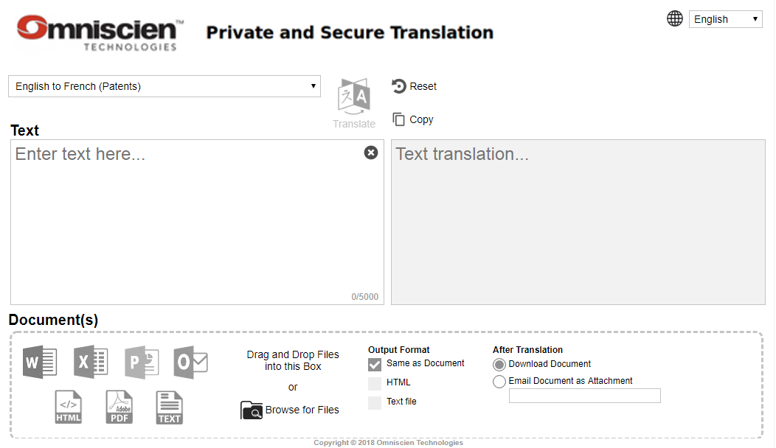

1. Testing translation screen

# How to translate

The translation page operate via web browser. You can translate text or drop file to translation.

## Translation page

Open the browser to do translation. Changing the IP address as appropriately.

<http://172.17.101.26/lsetx/TranslatePageTemplate.jsp>



1. Translation page

## Text Translation

Open the browser to do translation. Changing the IP address as appropriately.

<http://172.17.101.26/lsetx/TranslatePageTemplate.jsp>

**Step to translate text :**

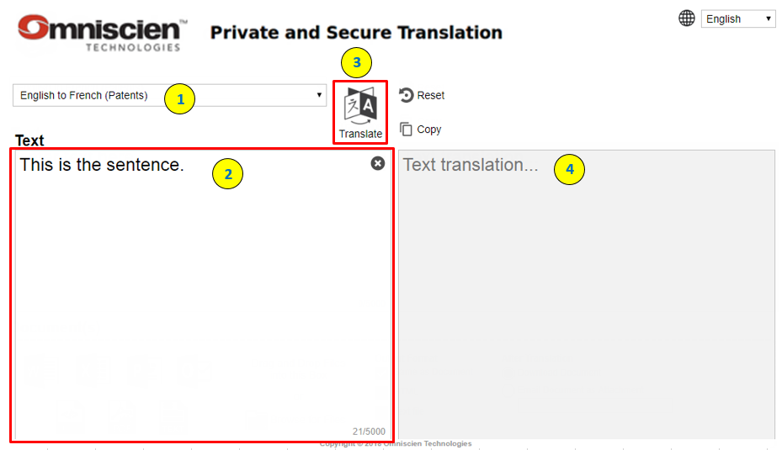

1. Step to translate text
2. Select language pair in list box.
3. Type text in translation box.
4. Click translation button.
5. The output will display in text translation box.

Another function in translation page.

1. Reset button , click reset button to clear translation text.
2. Copy button  , click copy button to copy translated text.
3. Change language , select language to change text in translation screen.

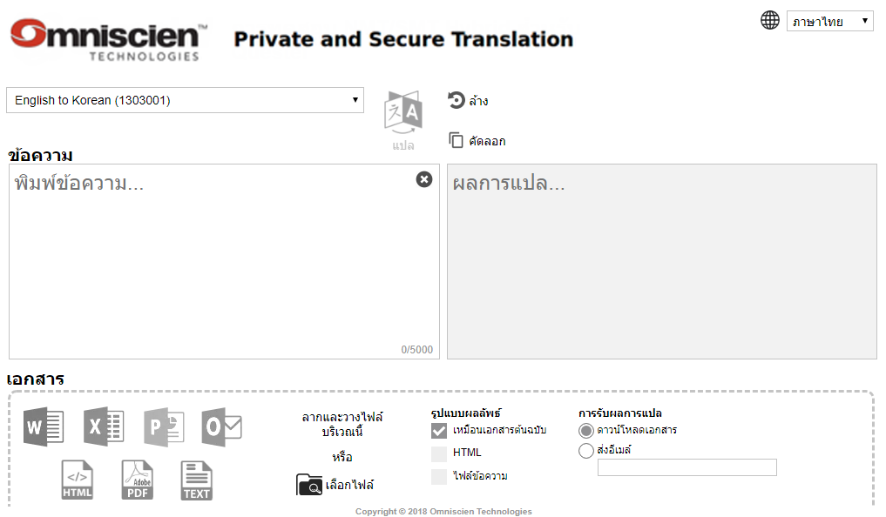

1. Changed language in translation screen

**Limitation** : The maximum character for text translation is 5,000 characters. If input text more than 5,000 characters, system will display error message “Maximum characters exceeded 14748/5000” and cannot click translate button.

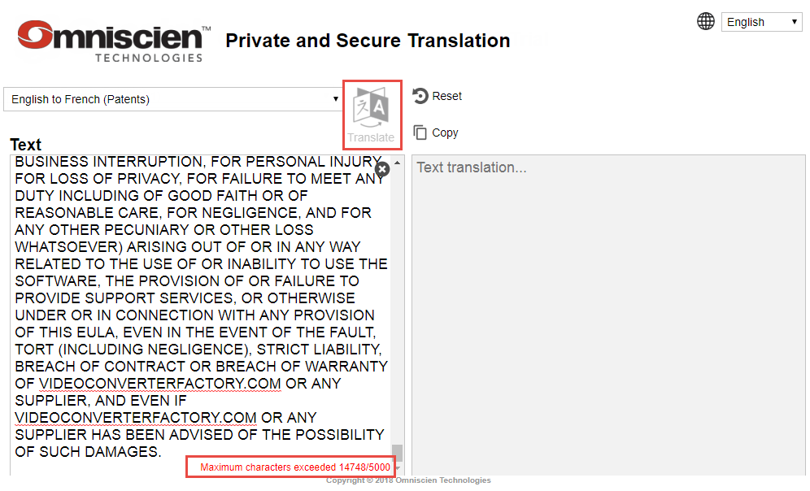

1. Warning exceeded input text translation

## File Translation

Open the browser to do translation. Changing the IP address as appropriately.

<http://172.17.101.26/lsetx/TranslatePageTemplate.jsp>

**File type translation**

|  |  |  |  |  |
| --- | --- | --- | --- | --- |
| No. | Input type | Output format | | |
| **Same as input format** | **HTML file** | **Text file** |
| 1 | Pain text | Yes | Yes | Yes |
| 2 | Microsoft Words (.doc, .docx) | Yes | Yes | Yes |
| 3 | Microsoft Excel (.xls, .xlsx) | Yes | Yes | Yes |
| 4 | Microsoft PowerPoint (.ppt, .pptx) | Yes | No | Yes |
| 5 | Microsoft Outlook (.msg)  (Not support Non-Romanize) | No | Yes | Yes |
| 6 | HTML file (.html) | Yes | Yes | Yes |
| 7 | Text file (.txt) | Yes | Yes | Yes |

**Remark :** The PDF file input not available now.

**Step to translate file :**

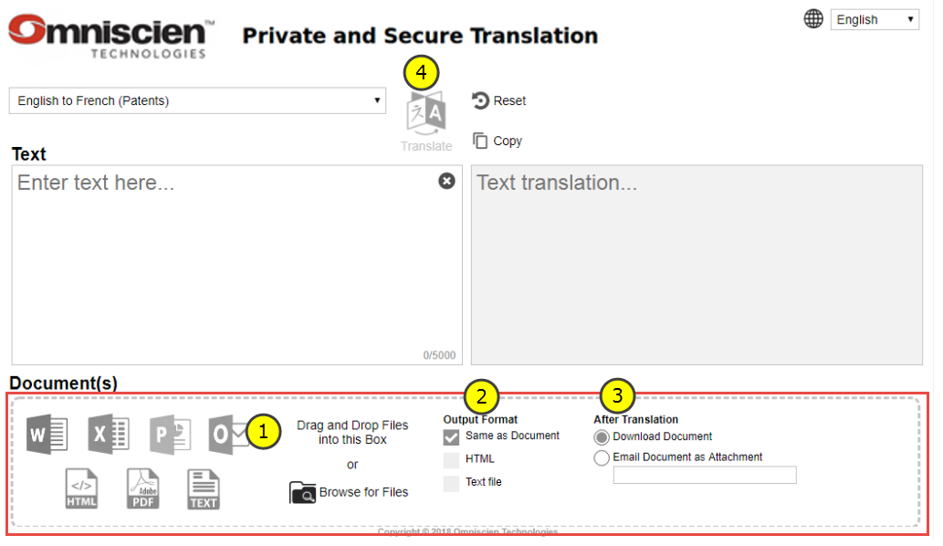

1. Step to translate file
2. Drag and drop file into red box or click Browse button. System should display document file list and file size in table. You can drop many files in same time.



1. Translate file list
2. Select output format, you can select multiple output format.
3. Select the method for receive output file Download Document or Send output via email. In case select send mail, need to set SMTP configuration in XML setting and input email in textbox.

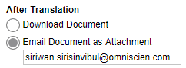

1. After translation : method for receive translation output
2. Click translation button. System should display translation status table about document file name, file size, language pair, after translation (method to get output) and job status.

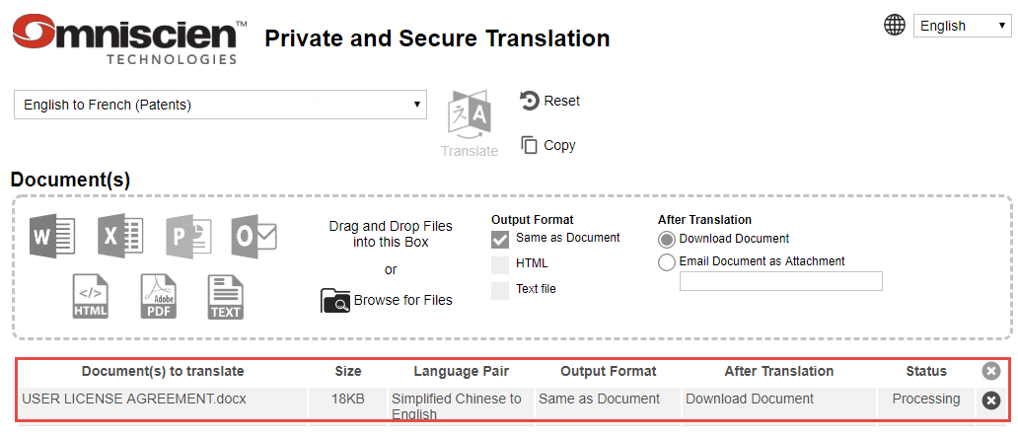

1. Translate text
2. Once finish translation, the status should change to “Complete”.

You can click Complete to download the output.



1. Completed translation

For send output via email, you will see the recipient mail in After Translation column. The recipient will receive output file when the status change to complete.



1. Recipient mail
2. Clear job history

To clear the completed job, please click buttonin each row. You cannot clear job that during processing or queue.



1. Clear job

To clear all jobs history, please click clear button in header table. In case some job not complete, you will cannot click clear button.

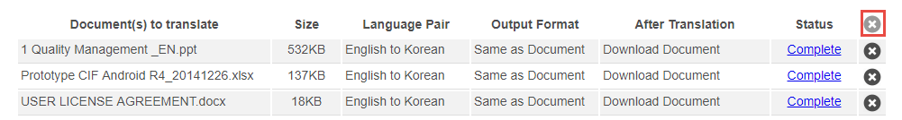

1. Clear all jobs history

# Appendices

## 

## Appendix A : Setup java script in a system

The Java script file is belong to customer site. You can implement and apply the java script to handle your data by yourself. The LSETS maintenance will not cover customer java script.

**Step to setup java script :**

1. Login to a host machine and copy a file to a path below.

|  |
| --- |
| cp your-file.js /home/dockeruser/lsets/data/lse-data/account/00002/00001/  Example: cp default.1303001.js2 /home/dockeruser/lsets/data/lse-data/account/00002/00001/ cp default.1303001.js7 /home/dockeruser/lsets/data/lse-data/account/00002/00001/ |

1. Run reset system.

Login to web admin screen and please click the Reset System tab, then the **Reset System** button.

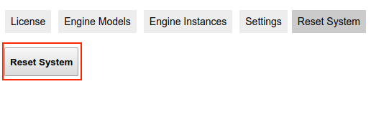

1. Reset system screen
2. Once done, a success message will display. After success you will can do translation.

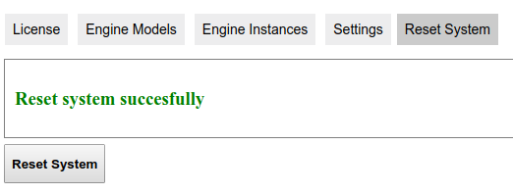

1. Reset system successful